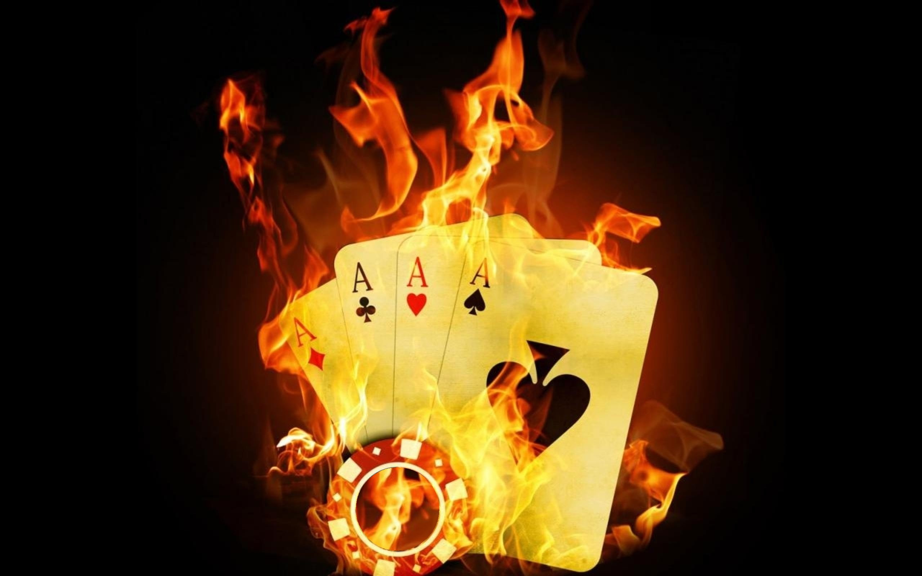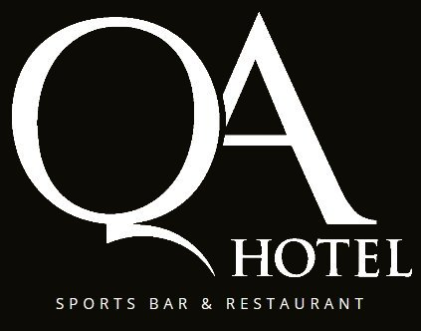

**QUEEN’S ARMS HOTEL**

**64 James St Fortitude Valley**

**(Corner James & Arthur Streets)**

**On-site parking (1st Hour Free). On site ATM. Great selection of Food & Drinks.**

**BOUNTY - 11.00am Rego - Noon START**

**$125 ($80 + $30 BOUNTY + $15) Buy-In, 50k Start Stack No Re-Buys, 30 min Blinds, Late Rego till 3:00pm**

**NLHE - 2.00pm Rego - 3:00pm START**

**$60 ($50 + $10) Buy-In, 40k Start Stack No Re-Buys, 15 min Blinds, Late Rego till 5:00pm**

**DOUBLE HEADER**

**SUNDAY 11th AUGUST**